2024 Camp Hodgepodge Bake Off!

Greetings and thank you so much for being part of our cook-off/bake-off! Before the event happens, we would like to give you some information that may be beneficial for your young chef.

Our theme for this bake/cook off is Desserts. By definition, Desserts
n.
A sweet course eaten at the end of a meal.

We are providing the following:

Sugar
Vanilla
Heavy cream
Butter
Eggs
Vegetable oil
Baking Powder/Soda
Flour
Salt/Pepper
Whisks
Measuring cups
Baking pans
Spatulas
Frying pans
Various sizes of pots
Various sizes of mixing bowls
Two handheld mixers

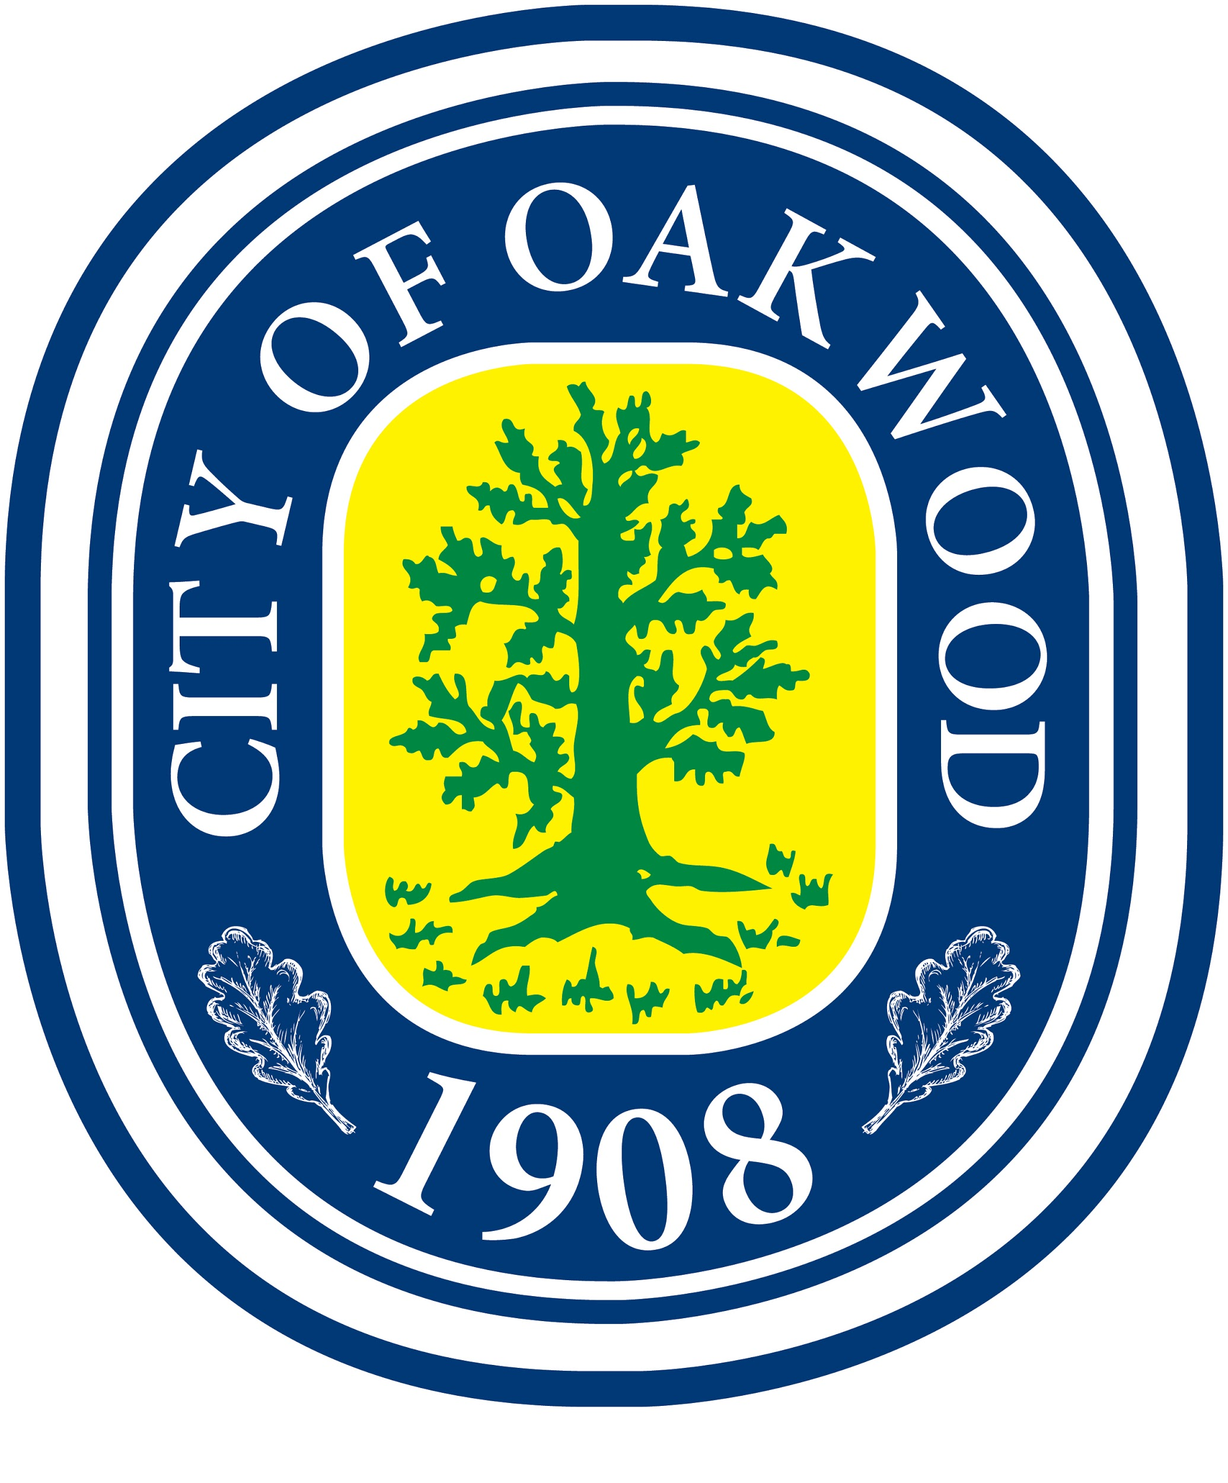
There will be NO parent help allowed during preparation. The OCC will have a couple of staff members present to help with the preparation. Everyone will have approximately one and half hours to complete your dessert. Please make sure you choose a dessert that will fill up the time slot, (something that won’t take just 5-10 minutes to make.) If you have any questions about the supplies/ingredients provided or anything else you can contact Thomas Hayes at 298-0775 or hayes@oakwood.oh.us Also, please try to be at the event 10 minutes prior so that all the chefs can begin on time. Thank you!

